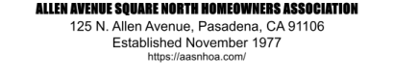

Dear Homeowners,
Please be advised that effective April 7, 2027, the fine schedule will be increased to $100 per incident.
This adjustment is being implemented to ensure standard compliance and maintain the integrity of our operations. All incidents occurring on or after this date will be subject to the new rate.
We appreciate your attention and continued commitment to our operational standards. If you have any questions regarding this update, please reach out to Liza Nicolleti/ Property Manager.
Best regards,
Liza Nicollet
Property Manager
PCM

.

